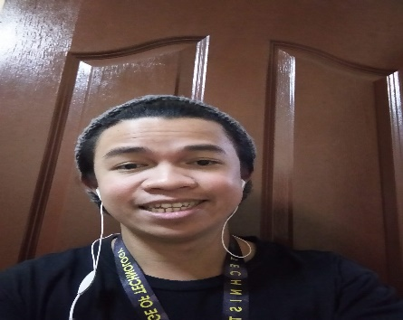**Edmond G. Esquilon**

**(Written on November 16, 2022)**

To start my name is Edmond Esquilon, you could also call me Mond since my Mom always called me that since I was young. My birthday is March 28th, 1994. And I grew up in a broken family.

**Childhood in Baguio City (1994-2006)**

I grew up in Baguio City, back then my father worked as a construction worker and attendant in a bowling alley while my mother is a housewife. I have 2 siblings: 1 older brother, and 1 older sister, and I am the youngest of them. 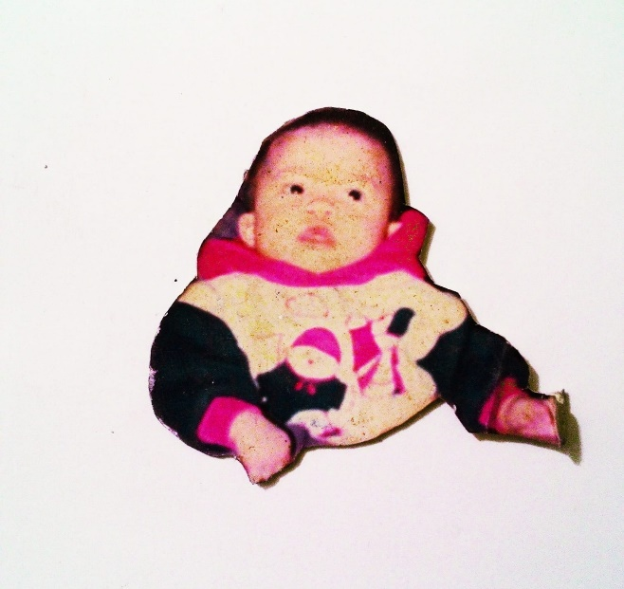

We were a pretty average family back in those years. As a family, we go on church every Sunday. Play around with my older siblings in the dirt, back when we still live under the bowling alley where my late father used to work.

As the years pass around year 2000 my father brought us to a place where our relatives from the father side lives, in there he built our small house. In there I learn that I have cousins that I could play with.

**Elementary School Days (2000 - 2006)**

To me, I’m just an average student back when I was in elementary, but my mother always taught us that we need to get high grades and good performance at school that’s why I always tried to reach the top 1 of the class, but I never did. Since I was a crybaby back then I’m always getting bullied since I’m an easy pick for bigger kids. It is also the reason why I’m getting scared to go to school back then. Until my older brother taught me how to play video games. Playing video games back then kept me to go to school even though I’m getting bullied. To me playing video games is the only thing that could heal me mentally that time. And also it became the reason why I’m not performing well at school.

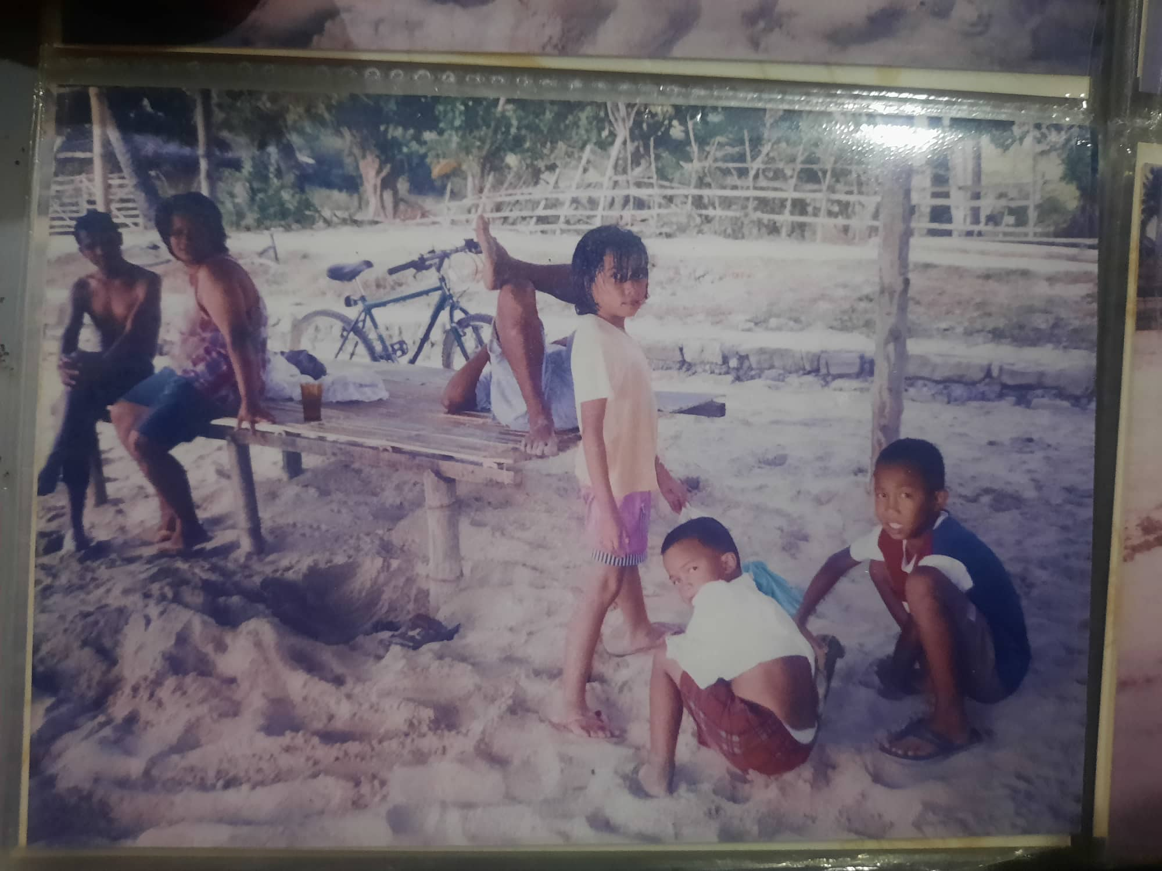Our family is still the same until the year 2001 the relationship between my father and mother is worsening at that time. Every night they always argue about something that I don’t understand at that time. I always hear my Mother cry every night they argue and at that time an anger emotion built up inside my heart towards my father.

Our life continued to be like that until the year 2003, one night my father went home drunk with liquor, and they started to argue again. And then my father physically abused my mother. We cried that night because of what was happening. Then the morning comes, our mother is not at home and we can’t find her. She left us with our drunk father. Until one day our mother showed up at school asking us if we want to come and live with her, and since our father doesn’t really show his affection to us his children. We chose to side with our mother.

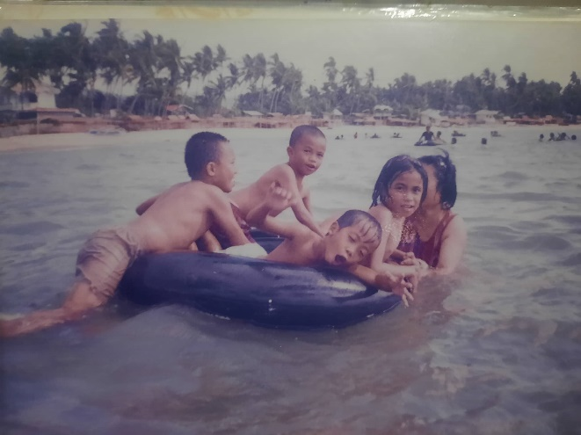The pictures that I’ve shown is the unforgettable memories of our family as a whole. Sometimes I wished that we can be whole again.

**High school Teenage Years (2007-2012)**

This is the time when I became rebellious, possibly as a result of what happened to our family; this is also the time when my older brother moved to the province to attend school, living with relatives on my mother's side. Another reason is that my mother cannot afford to send all three of us to school, and the two of us occasionally fight, and our mother cannot handle the stress. During my first year being a freshman I became a happy-go-lucky kind of person, I became friends with people who always invites me to not go to school to only play video games. I always thought that everything will go okay. There are no consequences in doing those kinds of things, thinking it was normal. Until it causes a problem for my mother but for me being stubborn I didn’t give much thought of it. Until my mother almost gave up on me but still she believes in me, that’s why after 1st year high-school she sent me back to our province in Ilocos Sur to help my late grandfather and uncle in the fields. Back then my late grandfather taught me how to value hard work as a farmer, they always say this line to me “ag-anus ka nu kayat mo sumayaat ti biyag mo” (If you want to live a happy life, you must put in the effort.). And it became a second nature for me. After a year and half in the province I came back to Baguio to continue my high-school. My sophomore year went normal I finished it being part of the top 10 in the class. Until before my junior year I’ve became friends again with what you can call BI (bad influence) there I started to do again what I’m doing back when I was a freshman, thankfully It didn’t cause much problem for my mother but still she warned me. And my senior year comes I’ve become somewhat lazy in school that I just go to school just for the allowance I tried to change that time but still it felt like there’s still something missing. A huge factor for me to change my way of thinking but still I didn’t found it, until I graduated high school, with some slight problems.

**Post-graduation (2012-2015)**

After my graduation in high school my older brother is already in his 2nd year of college, my mom said that I should not go to college just yet and let my older brother finish his first. My fights with my older brother became less before he started his college here in Baguio and sometimes are interactions became less since he’s busy with his college life but sometimes we do fight with little things. Afterwards the owner and also a friend of mine of the Internet Café that I used to play back when I was in high-school asked me if I want to work there as a staff or attendant in the internet shop. Then months have passed my elder sister got pregnant, our mother was infuriated. She always thought that my elder sister can finish her vocation course but instead she chose to have a family. Our mother had no choice but to forgive her. Months have passed and my elder sister gave birth to my niece. My work at the internet shop continued for 2 years with me earning a little to none. Until my older brother graduated and got a job. One day we had a fight with my brother because of it my mother scolded him, saying that he is the eldest and he should act like one and then they had an intense argument, I remembered my brother saying that I’m the favorite of our mother and always the one being sided with. Hearing those words of his made me think that it’s probably true and it made me feel pity for my brother. After their argument I thought that I should stop interacting with my brother in that way, we will have less fights or so. I also thought that it will help him have a favor with our mother. Time has passed my relationship with my brother gone colder, until one day he had an intense argument with our mother regarding with the help of paying some bills. But my plan of not interacting with my brother backlash to me, it seems that he still thinks that I’m the favorite of our mother. And that he said to our mother that I should be the one helping on that matter since I’m her favorite child. Until our mother said some harsh words to him, she really didn’t meant to say it. I know since our mother has a sharp tongue when her emotions are riled up. But my brother took it hard. Then some weeks passed, my brother suddenly said that he’s leaving the house. Our mother was angered by his decision but still, it didn’t stop my brother from leaving the house. Later that night our mother cried as if she was giving up, as I look at her I realized that she became older, she had more wrinkles and white hair and I think to myself why didn’t 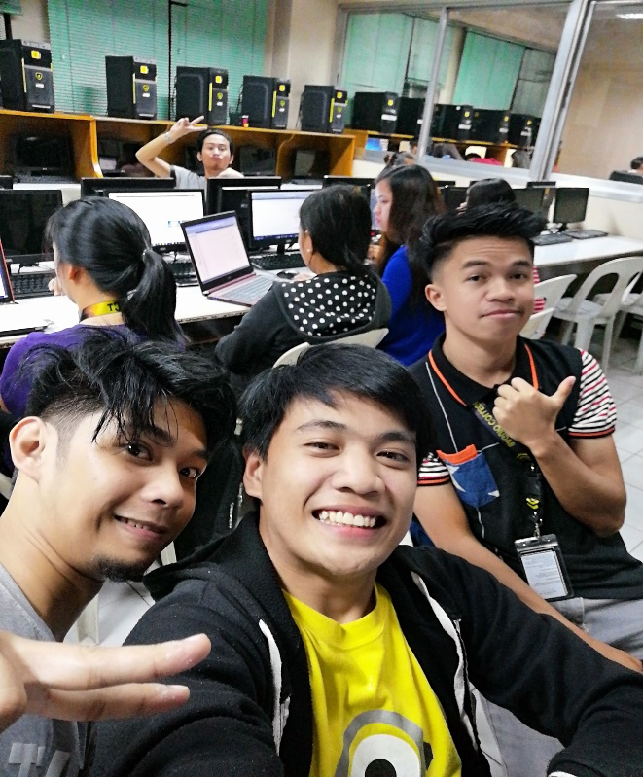realize that back when I was in high school, I asked myself over and over. And I looked at her again and at that moment it broke my heart to pieces it made me realize that the one that I’m seeking is not somewhere or something that I need before I change myself for the better. Because it is already beside me all the time the person giving her all, sacrificing her all just for us her children despite her being a single parent. A time has passed ever since our brother left the house and my elder sister became a single parent too, she broke up with her spouse because of some disputes that they can’t fix together. Her becoming a single parent had a huge burden again for our family since no one is going to babysit her child and she needs to work, I in the other hand also left the internet shop that I’m working too since the management is changing. And as I have nothing to do anymore I sacrificed a years’ time to babysit her child before I could enroll for the next college school year.  
  
**College Days (2016-2020)**

Because of my experience during the high school days I thought to myself that during my freshman year I should find good circle of friends whom I can share bonds with and build each other up throughout our schooling days.

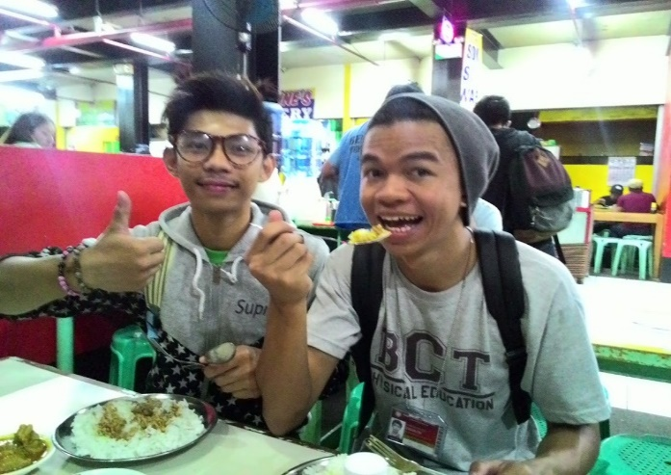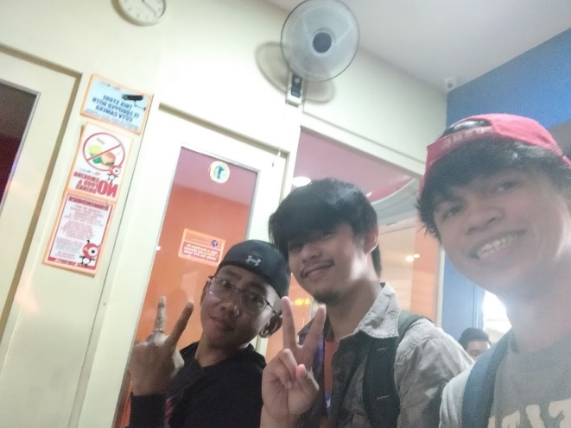Thankfully I met people who can I grow with. As I go throughout my freshman year I really did become better than I was during my high school days, I’ve become more active in school, challenging myself and having fun as well.

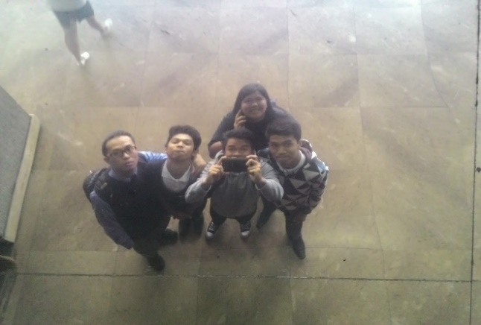Changing myself for the better and for the sake of someone who is precious to me is hard at first but as I go throughout my college life as a freshman I got to experience many things and the more I dwell in it I found many sides of myself that I couldn’t imagine doing, like participating to a choir, becoming a proxy for student body organization as business manager and doing well to academics and volunteering in some extracurricular activities in school.

During those times I think that I really do change for the better since I’m seeing results that I never expected to be like becoming part of the dean’s list during my sophomore year. I also experienced falling in love for real with someone.  
 As the days goes I’ve become a senior in college, the year where I also experience being heart broken. But still I continued what I’ve been doing from the start and for me everything that I experienced is a life fulfillment. I did my best until I reached the point where we will having our thesis, At that time I thought this it, after this I’ll be graduating and I’ll be standing on the stage together with my mother since I’ll be graduating as a honor student at that time, but it didn’t happen because of the pandemic.

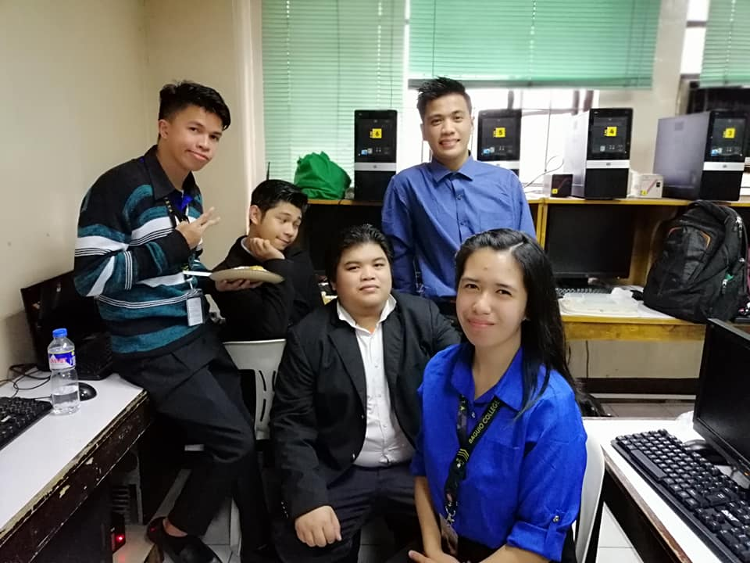It saddened me because I thought that I can make my mother feel proud of me when I stand with her on the stage but there’s nothing I can do reality is harsh.

**Pandemic (2020 - Present)**

After graduating, I expected to be able to find work quickly, but the pandemic made it much more difficult. As a result, the situation in our home has deteriorated significantly, particularly in my mother's and elder sister's jobs. And since I can’t land any job and there’s no one to look for my elder sisters children my mother asked me to take care of them until she can retire from her job so that she’ll be the one to take care for them. Then her retirement came, after that I made myself busy searching for jobs so that I can help with the situation in the house but unfortunately I can’t land any, until I stumbled a post in Facebook about a free bootcamp training of Web Development in Village88. (to be continued)